Study Guide for Final Exam Part 2
1. 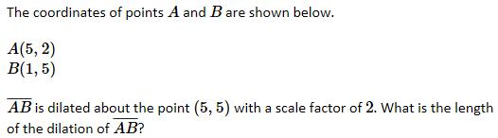
A. 5
B. 7
C. 10
D. 14

2.
A. 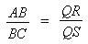
B.
C.
D. 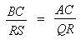

3. 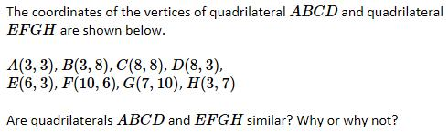
A.
B.
C. Yes, because all of their corresponding sides are equal in length.
D. No, because the lengths of the corresponding sides are not proportional.

4. Which of the following statements individually prove that two triangles are similar?
I. All pairs of corresponding sides are parallel.
II. All pairs of corresponding sides are proportional by the same ratio.
III. All of the corresponding angles are congruent.
A. I, only
B. II, only
C. II and III, only
D. I, II, and III

5. 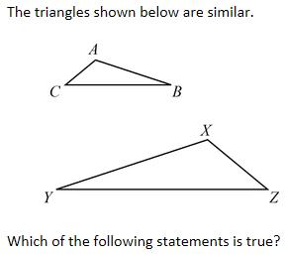
A. 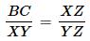
B. 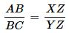
C. 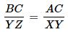
D. 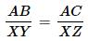

6. 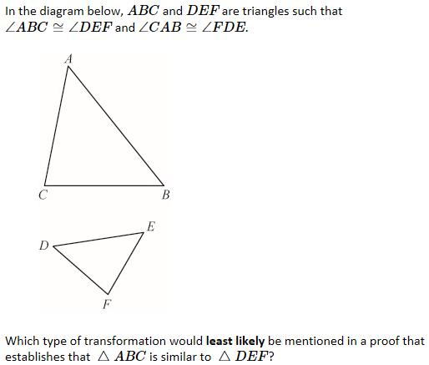
A. dilation
B. translation
C. rotation
D. shear

7. Which of the following properties of dilations would least likely be used to establish the AA criterion for two triangles to be similar?
A. The image formed when a line segment is dilated is another line segment.
B. If a dilation has a larger scale factor than another dilation, it produces larger images.
C. The image formed when an angle is dilated is another angle of equal measure.
D. The point located at the center of a dilation is not affected by the dilation.

8. 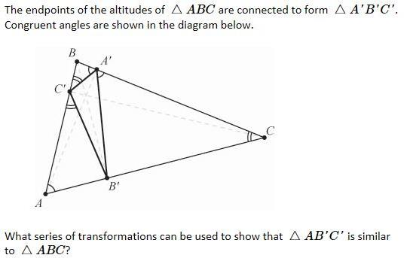
A. 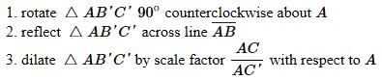
B. 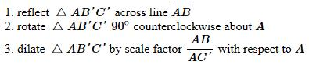
C. 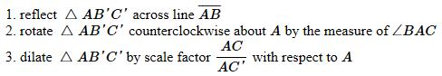
D. 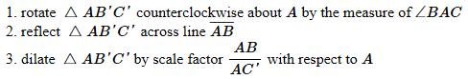

9. 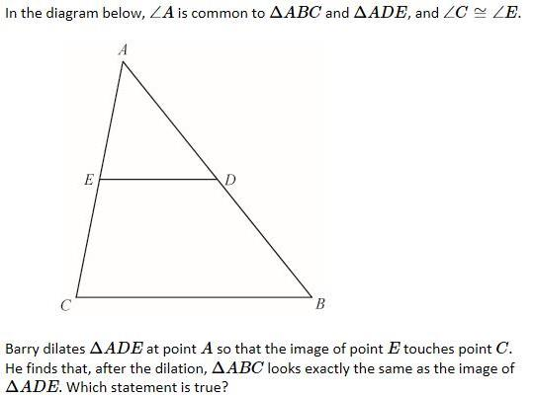
A.
B.
C.
D.

10. 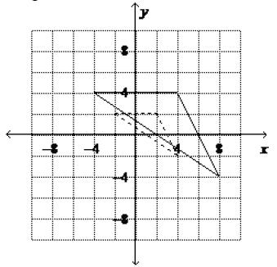
The dashed triangle is an image of the solid triangle. What is the scale factor of the image?
A. ¼
B. ½
C. ⅔
D. 2

11. 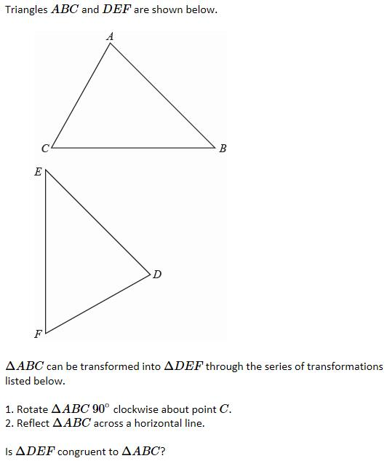
A. No, because the rotation changes the clockwise order of the angles.
B. No, because the reflection changes the clockwise order of the angles.
C. Yes, because the transformations taken are each rigid motions which preserve angle measure and segment length.
D.

12. 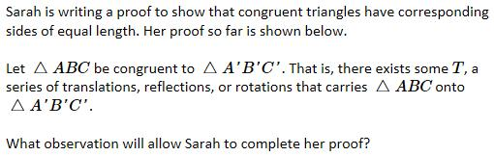
A.
B.
C. All translations, reflections, and rotations carry angles onto angles of the same measure.
D. All translations, reflections, and rotations carry line segments onto line segments of the same length.

13. 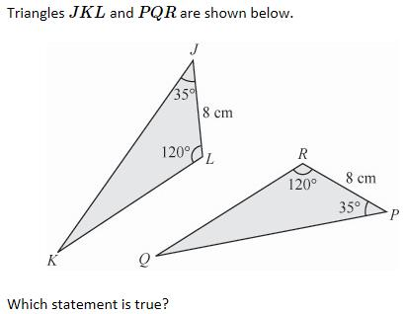
A.
B. The triangles are similar by AAA but they are not congruent.
C.
D.

14. 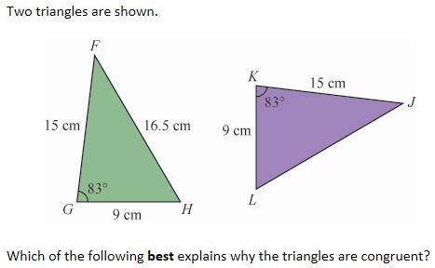
A.
B.
C.
D.

15. 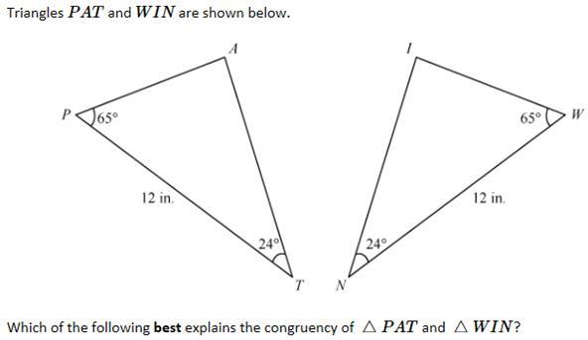
A. The triangles are not congruent because more information is needed.
B.
C.
D.

20. 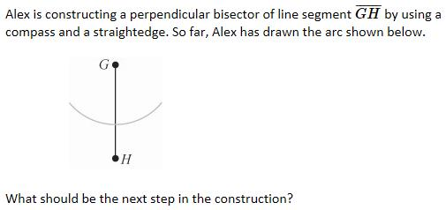
A. 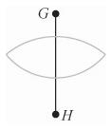
B. 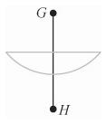
C. 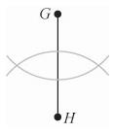
D. 