Study Guide Final Exam Part 3
1. 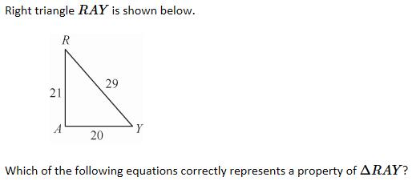
A. 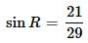
B. 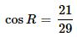
C. 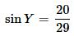
D. 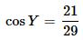

2. 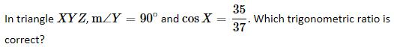
A. 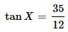
B. 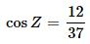
C. 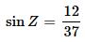
D. 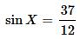

3. 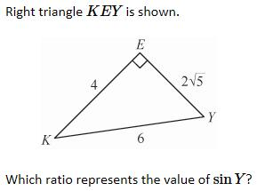
A.
B. 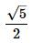
C. 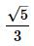
D. 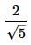

4. 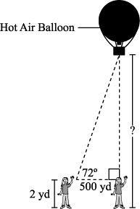
Sherri sees a hot air balloon at an angle of inclination of 72°. Sherri’s twin sister is standing directly beneath the hot air balloon, 500 yards away from Sherri, as shown in the diagram.
Sherri’s eye level is 2 yards above the ground. What is the height of the hot air balloon above the ground? Round your answer to the nearest yard.
A. 1072 yds
B. 1800 yds
C. 1541 yds
D. 2800 yds

5. 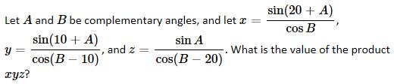
A.
B. 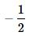
C.
D.

6.
A.
B.
C.
D.

7. 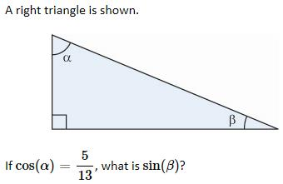
A.
B.
C.
D.

8. Which expression is equal to cos 40°?
A. sin 40°
B. sin 50°
C. cos 50°
D. cos 80°

9.
A.
B.
C.
D. 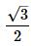

10. 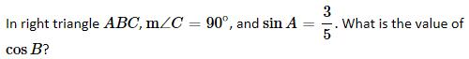
A.
B.
C.
D.

