Study Guide Final Exam Part 1
1. What is the rule for a reflection across the y-axis followed by a translation 7 units to the right and 7 units up?
A. (x' , y') = (x + 7 , -y + 7)
B. (x' , y') = (x - 7 , -y - 7)
C. (x' , y') = (-x + 7 , y + 7)
D. (x' , y') = (-x - 7 , y - 7)

2. Given and T_{h,k} (x,y) = (x + h,y + k) and P (-4, -3), what is T,_{-2,1}(P)?
A. P (6, 2)
B. P (2, 4)
C. P (-6, -2)
D. P (-3, -5)

3. 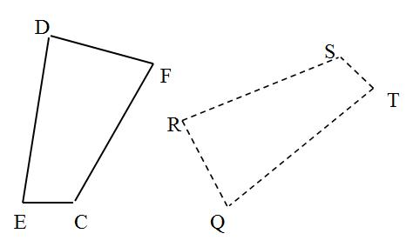
In the diagram, the dashed figure is the image of the solid figure. Name the image of ∠ E.
A. ∠ R
B. ∠ Q
C. ∠ E
D. ∠ T

4. The vertices of a triangle are P (-7, -4), Q (-7, -8), and R (3, -3). Name the vertices of the image reflected in the line y = x.
A. P` (4, 7), Q` (8, 7), R` (3, -3)
B. P` (4, -7), Q` (8, -7), R` (3, 3)
C. P` (-4, -7), Q` (-8, -7), R` (-3, 3)
D. P` (-4, 7), Q` (-8, 7), R` (-3, -3)

5. Describe in words the transformation represented by the translation (x + 2, y - 1).
A. 2 units to the right and 1 units down
B. 1 units to the right and 2 units down
C. 2 units to the left and 1 units down
D. 2 units to the left and 1 units up

6.
Name the type of symmetry for the figure.
A. reflection
B. rotation
C. rotation and reflection
D. no symmetry

7. Which of the following best describes a geometric dilation?
A. A transformation that turns a figure around a point
B. A transformation that slides a figure to a new location
C. A transformation that flips a figure across a line
D. A transformation that enlarges or reduces the size of a figure by a certain scale factor

8. 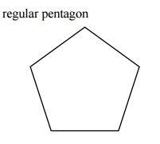
A regular pentagon such as the one shown above has how many lines of symmetry that will map it onto itself?
A. None
B. 1
C. 4
D. 5

9. 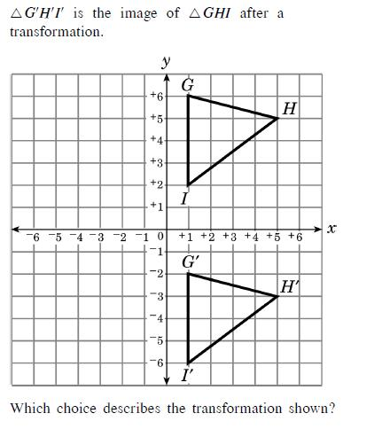
A. reflection over x-axis
B. reflection over y-axis
C. 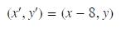
D. 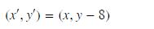

10. 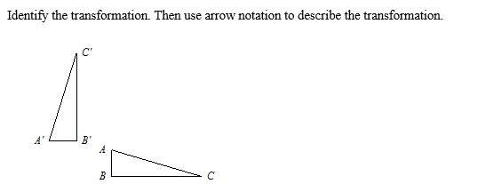
A.
B.
C.
D.

11.
A. 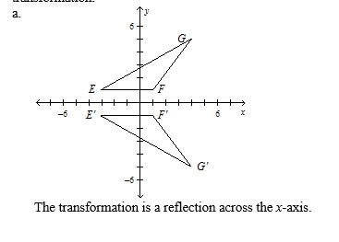
B. 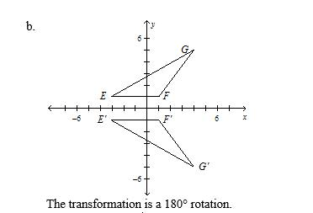
C. 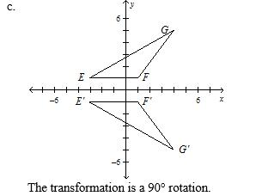
D. 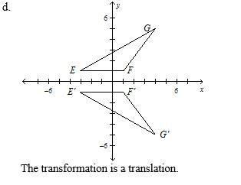

12. 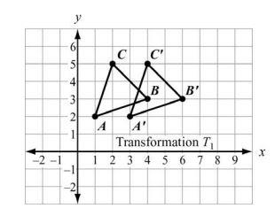
Which statement is NOT true about Transformation T?
A.
B.
C. The transformation has isometry.
D. The image of A moved 2 units UP

13. 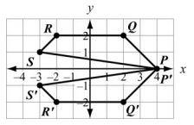
Which transformation is shown by the above figure?
A. Reflect over the y-axis.
B. Reflect over the x- axis.
C. Rotate 180 degrees
D. There is no transformation performed.

14. 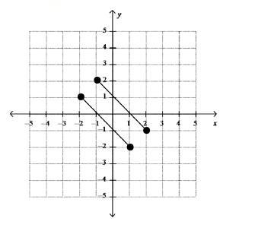
Joseph graphed the given set of parallel line segments. Describe the final image of the line segments after a reflection over the y-axis and a translation (x , y) --> (x + 2, y - 10)
A. The lines intersect at (-2, 1).
B. The lines do not intersect and are the same distance apart as the original set of lines.
C. The lines do not intersect and are further apart than the original set of lines.
D. The lines do not intersect and are closer together than the original set of lines.

15. 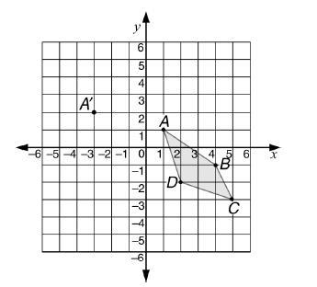
If figure ABCD is translated so that the image of point A' is at (-3, 2), then the coordinates of the image of point B will be
A. (0,0)
B. (-1, 4)
C. (-2, -1)
D. (-3, 1)

16. 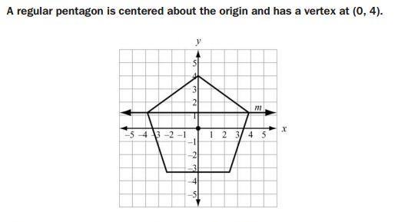
Which Transformation maps the pentagon to itself?
A. A reflection across line m
B. A reflection across x-axis
C. A clockwise rotation of 100 degree about the origin
D. A clockwise rotation of 144 degree about the origin

17. 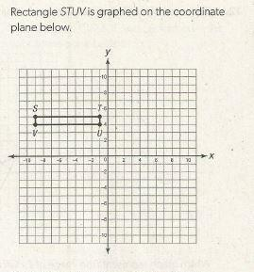
Which series of transformations will carry rectangle STUV onto itself?
A. Reflection over the y-axis, clockwise rotation by 180 degree about the origin, reflection over the y-axis.
B. Reflection over the x-axis, reflection over the y-axis, counterclockwise rotation by 270 degree about the origin.
C. Reflection over the y-axis, reflection over the x-axis, counterclockwise rotation by 180 degree about the origin.
D. Reflection over the x-axis, reflection over the y-axis, clockwise rotation by 90 degree about the origin.

18. After nonzero transformation K to polygon P has been performed four consecutive times, polygon P has returned to its original position in the plane. Which of the following could not describe transformation K?
A. A reflection over a fixed line
B. A rotation by 90 degree about a fixed point
C. A rotation by 180 degree about a fixed point
D. A translation by (a, b) units in the plane

19. 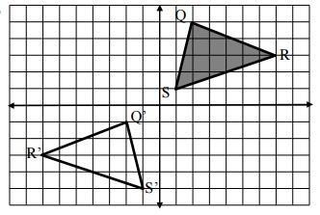
Which sequence of transformations will carry each pre image onto its image?
A. Translate 2 units to the left, then 6 units down
B. Translate 6 units DOWN, then Reflect over Y-axis
C. Rotate 180 degrees
D. Reflect over the x - axis, then translate 3 units to the left

20. 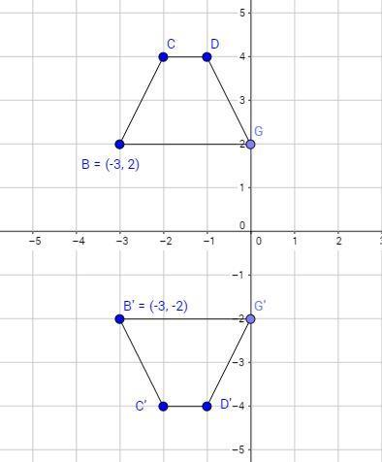
Which of the following sequence of transformations DOES NOT describe the transformation shown above?
A. Reflect over the x- axis.
B. Reflect over y = 1, the translate 2 units down
C. Translate 4 units down, then reflect over y = -2
D. Translate 2 units down, then reflect over the x-axis.

