Quiz 1: Transformations
Instructions: 1. Choose the best possible answer.
2. Bubble completely one answer.
1. | What is the rule for a reflection across the y-axis followed by a translation 7 units to the right and 7 units up?
 | A. | (x' , y') = (x + 7 , -y + 7)
 | B. | (x' , y') = (x - 7 , -y - 7)
 | C. | (x' , y') = (-x + 7 , y + 7)
 | D. | (x' , y') = (-x - 7 , y - 7)
2. | Given and T<sub>h,k</sub> (x,y) = (x + h,y + k) and P (-4, -3), what is T,<sub>-2,1</sub>(P)?
 | A. | P (6, 2)
 | B. | P (2, 4)
 | C. | P (-2, -2)
 | D. | P (-3, -5)
3. | 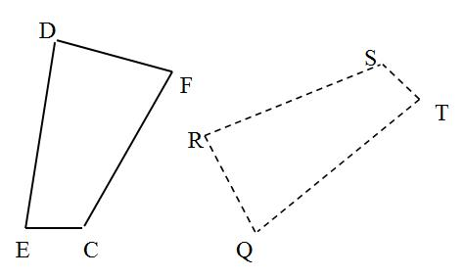  In the diagram, the dashed figure is the image of the solid figure. Name the image of ∠ E.
 | A. | ∠ R
 | B. | ∠ Q
 | C. | ∠ E
 | D. | ∠ T
4. | The vertices of a triangle are P (-7, -4), Q (-7, -8), and R (3, -3). Name the vertices of the image reflected in the line y = x.
 | A. | P` (4, 7), Q` (8, 7), R` (3, -3)
 | B. | P` (4, -7), Q` (8, -7), R` (3, 3)
 | C. | P` (-4, -7), Q` (-8, -7), R` (-3, 3)
 | D. | P` (-4, 7), Q` (-8, 7), R` (-3, -3)
5. | Describe in words the transformation represented by the translation (x + 2, y - 1).
 | A. | 2 units to the right and 1 units down
 | B. | 1 units to the right and 2 units down
 | C. | 2 units to the left and 1 units down
 | D. | 2 units to the left and 1 units up
6. | Name the type of symmetry for the figure.
 | A. | reflection
 | B. | rotation
 | C. | rotation and reflection
 | D. | no symmetry
7. | Which of the following best describes a geometric dilation?
 | A. | A transformation that turns a figure around a point
 | B. | A transformation that slides a figure to a new location
 | C. | A transformation that flips a figure across a line
 | D. | A transformation that enlarges or reduces the size of a figure by a certain scale factor
8. | 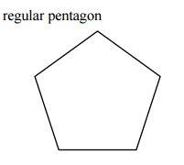  A regular pentagon such as the one shown above has how many lines of symmetry that will map it onto itself?
 | A. | None
 | B. | 1
 | C. | 4
 | D. | 5
9. | 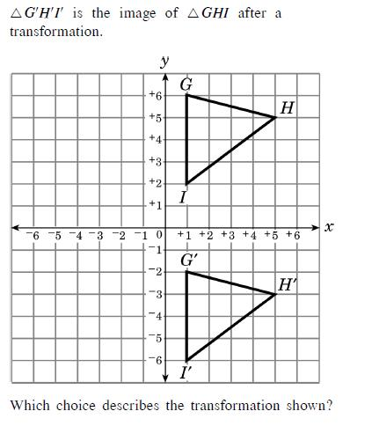
 | A. | reflection over x-axis
 | B. | reflection over y-axis
 | C. | 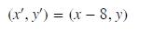
 | D. | 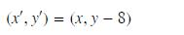
10. | 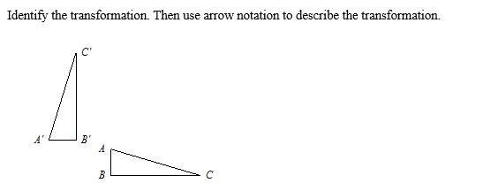
 | A.
 | B.
 | C.
 | D.
11.
 | A. | 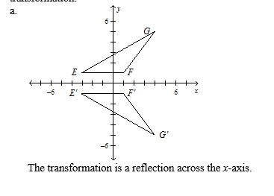
 | B. | 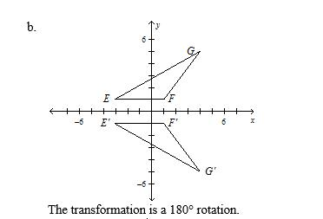
 | C. | 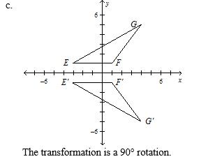
 | D. | 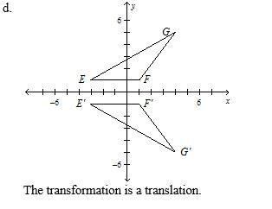
12. | 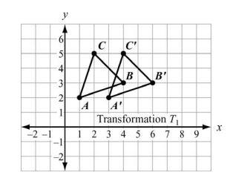  Which statement is NOT true about Transformation T?
 | A.
 | B.
 | C. | The transformation has isometry.
 | D. | The image of A moved 2 units UP
13. | 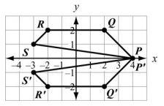  Which transformation is shown by the above figure?
 | A. | Reflect over the y-axis.
 | B. | Reflect over the x- axis.
 | C. | Rotate 180 degrees
 | D. | There is no transformation performed.
14. | 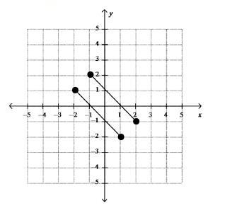  Joseph graphed the given set of parallel line segments. Describe the final image of the line segments after a reflection over the y-axis and a translation (x , y) --> (x + 2, y - 10)
 | A. | The lines intersect at (-2, 1).
 | B. | The lines do not intersect and are the same distance apart as the original set of lines.
 | C. | The lines do not intersect and are further apart than the original set of lines.
 | D. | The lines do not intersect and are closer together than the original set of lines.
15. | 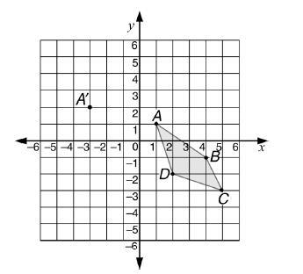  If figure ABCD is translated so that the image of point A' is at (-3, 2), then the coordinates of the image of point B will be
 | A. | (0,0)
 | B. | (-1, 4)
 | C. | (-2, -1)
 | D. | (-3, 1)
16. | 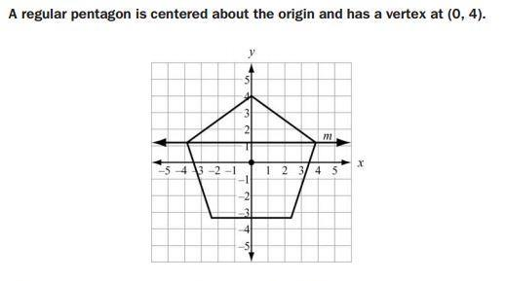  Which Transformation maps the pentagon to itself?
 | A. | A reflection across line m
 | B. | A reflection across x-axis
 | C. | A reflection across y-axis
 | D. | A clockwise rotation of 144 degree about the origin
17. | 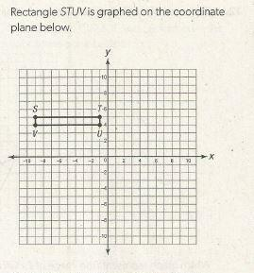  Which series of transformations will carry rectangle STUV onto itself?
 | A. | Reflection over the y-axis, clockwise rotation by 180 degree about the origin, reflection over the y-axis.
 | B. | Reflection over the x-axis, reflection over the y-axis, counterclockwise rotation by 270 degree about the origin.
 | C. | Reflection over the y-axis, reflection over the x-axis, counterclockwise rotation by 180 degree about the origin.
 | D. | Reflection over the x-axis, reflection over the y-axis, clockwise rotation by 90 degree about the origin.
18. | After nonzero transformation K to polygon P has been performed four consecutive times, polygon P has returned to its original position in the plane. Which of the following could not describe transformation K?
 | A. | A reflection over a fixed line
 | B. | A rotation by 90 degree about a fixed point
 | C. | A rotation by 180 degree about a fixed point
 | D. | A translation by (a, b) units in the plane
19. | 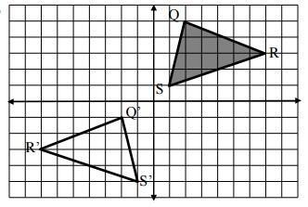  Which sequence of transformations will carry each pre image onto its image?
 | A. | Translate 2 units to the left, then 6 units down
 | B. | Translate 6 units DOWN, then Reflect over Y-axis
 | C. | Rotate 180 degrees
 | D. | Reflect over the x - axis, then translate 3 units to the left
20. | 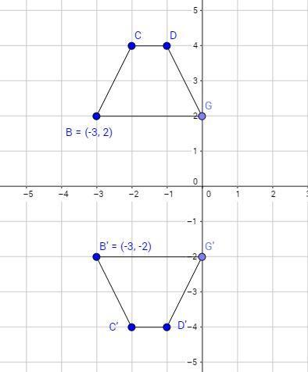  Which of the following sequence of transformations DOES NOT describe the transformation shown above?
 | A. | Reflect over the x- axis.
 | B. | Reflect over y = 1, the translate 2 units down
 | C. | Translate 4 units down, then reflect over y = -2
 | D. | Translate 2 units down, then reflect over the x-axis.

