High School GSE Geometry
Unit 3 GSE Geometry District Common Assessment
1. | 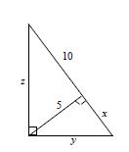  Find x, y, and z. Give your answers in simplest radical form
 | A. | 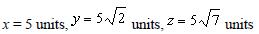
 | B. | 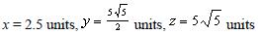
 | C.
 | D.
2. | Write cos(67°) in terms of its co-function
 | A. | sin(67°)
 | B. | sin(23°)
 | C. | cos(23°)
 | D. | sec(67°)
3. | 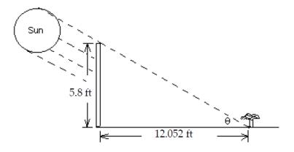  A 5.8-ft fence is 12.052 ft away from a plant in the direction of the sun. It is observed that the shadow of the fence extends exactly to the bottom of the plant. (See drawing) Find θ, the angle of elevation of the sun at that time. Round the measure of the angle to the nearest tenth of a degree
 | A. | θ = 27.1°
 | B. | θ = 25.7°
 | C. | θ = 25.9°
 | D. | θ = 25.5°
4. | 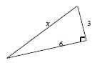  Find the value of x. Express your answer in simplest radical form.
 | A. | x = 3√5
 | B. | x = 9√5
 | C. | x = 3√3
 | D. | x = 5√3
5. | 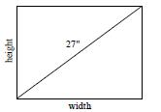  The size of a TV screen is given by the length of its diagonal. The screen aspect ratio is the ratio of its width to its height. The screen aspect ratio of a standard TV screen is 4:3. What are the width and height of a 27" TV screen?
 | A. | width: 21.6 in., height: 16.2 in.
 | B. | width: 16.2 in., height: 21.6 in.
 | C. | width: 21.6 in., height: 5.4 in.
 | D. | width: 5.4 in., height: 21.6 in.
6. | 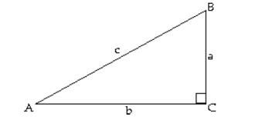  Let B = 65.4834° and c = 3954.5 m. Solve the right triangle.
 | A. | A = 24.52°; a = 1640.95 m; b = 3552.58 m
 | B. | A = 24.52°; a = 1548.19 m; b = 3582.67 m
 | C. | A = 24.52°; a = 1705.58 m; b = 3597.97 m
 | D. | A = 24.52°; a = 1640.95 m; b = 3597.97 m
7. | 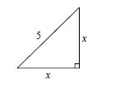  Find the value of x. Express your answer in simplest radical form.
 | A. | 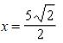
 | B.
 | C. | 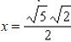
 | D. | 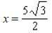
8. | 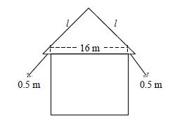  An architect designs the front view of a house with a gable roof that has a 45°-45°-90° triangle shape. The overhangs are 0.5 meter each from the exterior walls, and the width of the house is 16 meters. What should the side length l of the triangle be? Round your answer to the nearest meter.
 | A. | 12 m
 | B. | 11 m
 | C. | 24 m
 | D. | 25 m
9. | 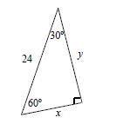  Find the values of x and y. Express your answers in simplest radical form
 | A. | x=12√2, y=12
 | B. | x=12√3, y=12
 | C. | x=12, y=12√2
 | D. | x=12, y=12√3
10. | 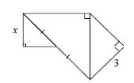  Each triangle is a 45°-45°-90° triangle. Find the value of x.
 | A. | 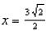
 | B. | 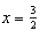
 | C.
 | D. | 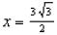
11. | 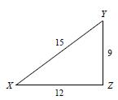  Write the trigonometric ratio for cos X as a fraction and as a decimal rounded to the nearest hundredth.
 | A. | 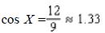
 | B. | 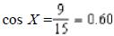
 | C. | 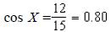
 | D. | 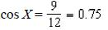
12. | Use your calculator to find the trigonometric ratios sin 79, cos 47, and tan 77. Round to the nearest hundredth.
 | A. | sin 79 = -0.99, cos 47 = -0.44, tan 77 = - 32.27
 | B. | sin 79 = -0.44, cos 47 = -0.99, tan 77 = - 32.27
 | C. | sin 79 = 0.68, cos 47 = 0.98, tan 77 = 4.33
 | D. | sin 79 = 0.98, cos 47 = 0.68, tan 77 = 4.33
13. | 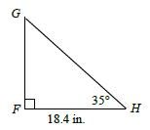  Find GH. Round to the nearest hundredth.
 | A. | GH = 32.08 in.
 | B. | GH = 15.07 in.
 | C. | GH = 22.46 in.
 | D. | GH = 26.28 in.
14. | 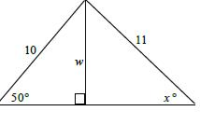  Find the value of w and then x. Round lengths to the nearest tenth and angle measures to the nearest degree.
 | A. | w = 7.7, x = 44
 | B. | w = 6.4, x = 54
 | C. | w = 7.7, x = 54
 | D. | w = 6.4, x = 44
15. | Jessie is building a ramp for loading motorcycles onto a trailer. The trailer is 2.8 feet off of the ground. To avoid making it too difficult to push a motorcycle up the ramp, Jessie decides to make the angle between the ramp and the ground 15. To the nearest hundredth of a foot, find the length of the ramp.
 | A. | 2.90 feet
 | B. | 10.82 feet
 | C. | 0.72 feet
 | D. | 10.45 feet
16. | Use the trigonometric ratio sinA = 0.38 to determine which angle of the triangle is ∠A
 | A. | ∠2
 | B. | ∠1
 | C. | ∠3
 | D. | No solution
17. | Find sin ∠A to the nearest hundredth.
 | A. | sin ∠A = 2.24
 | B. | sin ∠A = 0.50
 | C. | sin ∠A = 0.45
 | D. | sin ∠A = 0.89
18. | The coordinates of the vertices of ΔRPQ are R(2, -1), P(2, 2), and Q(-2, -1). Find m∠P.
 | A. | m∠P = 42°
 | B. | m∠P = 37°
 | C. | m∠P = 93°
 | D. | m∠P = 53°
19. | An eagle 300 feet in the air spots its prey on the ground. The angle of depression to its prey is 15. What is the horizontal distance between the eagle and its prey? Round to the nearest foot.
 | A. | 723 ft
 | B. | 1,159 ft
 | C. | 310 ft
 | D. | 1,120 ft
20. | A pilot flying at an altitude of 1.8 km sights the runway directly in front of her. The angle of depression to the beginning of the runway is 31°. The angle of depression to the end of the runway is 23°. What is the length of the runway? Round to the nearest tenth of a kilometer.
 | A. | 1.3 km
 | B. | 0.9 km
 | C. | 2.9 km
 | D. | 1.2 km

