High School GSE Geometry
Unit 2 GSE Geometry District Common Assessment
1. | 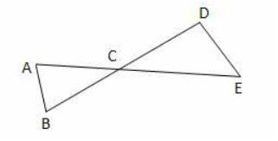  Given: AE and BD bisect each other at C. Which could be used to prove  ∆ABC ≅ ∆EDC?
 | A. | (SSS) If 3 sides of one triangle are congruent to 3 sides of another triangle, then the triangles are congruent.
 | B. | (SAS) If 2 sides and the angle between them in one triangle are congruent to 2 sides and the angle between them in another triangle, then the triangles are congruent
 | C. | (ASA) If 2 angles and the side between them of one triangle are congruent to 2 angles and the side between them of another triangle, then the triangles are congruent.
 | D. | (AAS) If 2 angles and a side not between them are congruent to 2 angles and a side not between them of another triangle, then the triangles are congruent.
2. | 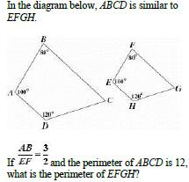
 | A. | 27
 | B. | 18
 | C. | 15
 | D. | 8
3. | 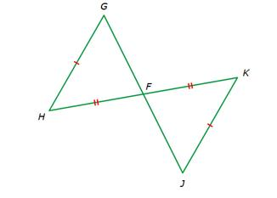  Which rule explains why these triangles are congruent?
 | A. | SSS
 | B. | SAS
 | C. | AAS
 | D. | None of the above
4. | 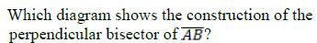
 | A. | 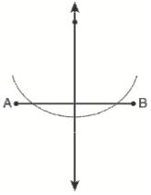
 | B. | 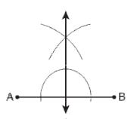
 | C. | 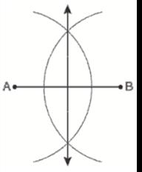
 | D. | 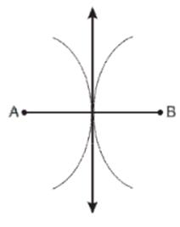
5. | Triangle ABC is rotated 45˚ about a point C in a clockwise direction. What is the relationship between the triangle ABC and its image A'B'C'?
 | A. | They are congruent.
 | B. | Each side of A'B'C' is 45 times as large as the sides of ABC.
 | C. | Each angle of A'B'C' is 45˚ larger than the angles of ABC.
 | D. | They have no relationship to each other.
6. | 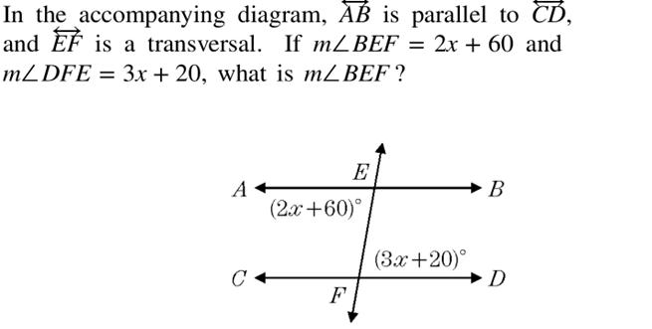
 | A. | 100
 | B. | 20
 | C. | 140
 | D. | 40
7.
 | A. | CPCTC
 | B. | SAS
 | C. | ASA
 | D. | SSS
8. | 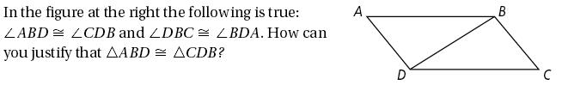
 | A. | SAS
 | B. | ASA
 | C. | SSS
 | D. | CPCTC
9. | 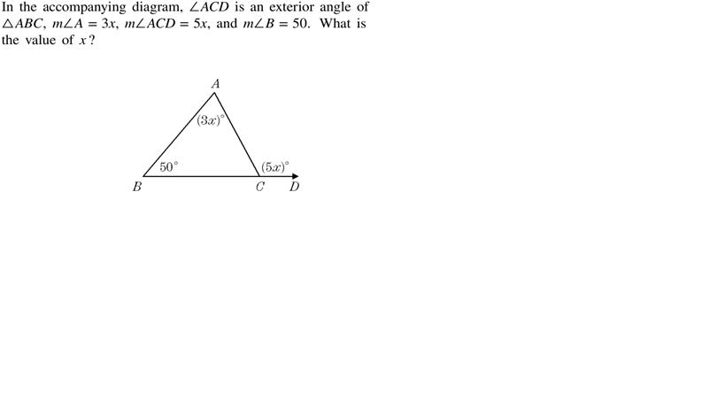
 | A. | 25
 | B. | 30
 | C. | 60
 | D. | 100
10. | 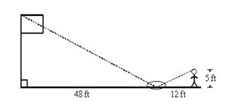  Michele wanted to measure the height of her school’s flagpole. She placed a mirror on the ground 48 feet from the flagpole, then walked backwards until she was able to see the top of the pole in the mirror. Her eyes were 5 feet above the ground and she was 12 feet from the mirror. Using similar triangles, find the height of the flagpole to the nearest tenth of a foot.
 | A. | 20 ft
 | B. | 38.4 ft
 | C. | 55 ft
 | D. | 25 ft
11. | 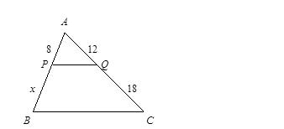  Use the Triangle Proportionality Theorem to find x, given that PQ || BC.
 | A. | 12
 | B. | 6
 | C. | 20
 | D. | 24
12. | 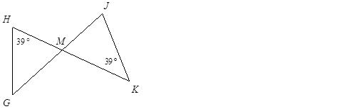  Are the two triangles similar? How do you know?
 | A. | yes, by SSS ~
 | B. | yes, by SAS ~
 | C. | no
 | D. | yes, by AA ~
13. | 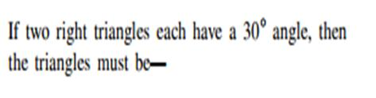
 | A. | similar
 | B. | congruent
 | C. | obtuse
 | D. | equilateral
14. | 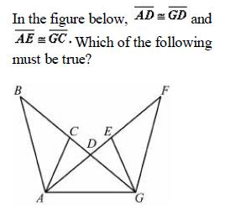
 | A.
 | B.
 | C.
 | D.
15. | 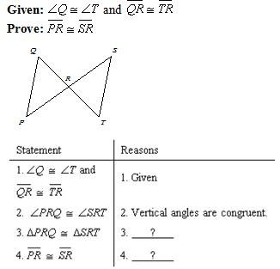  Supply the missing reason for the given proof.
 | A. | ASA; Substitution
 | B. | SAS; CPCTC
 | C. | AAS; CPCTC
 | D. | ASA; CPCTC
16. | 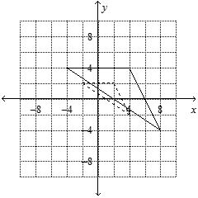  The dashed triangle is an image of the solid triangle. What is the scale factor of the image?
 | A. | ¼
 | B. | ½
 | C. | ⅔
 | D. | 2
17. | 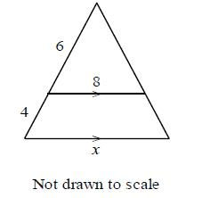  Explain why the triangles are similar. Then find the value of x.
 | A. | SSS Postulate; 5⅓
 | B. | AA Postulate; 13⅓
 | C. | SAS Postulate; 13⅓
 | D. | AA Postulate; 5⅓
18. | 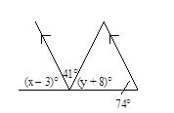  Find the values of x and y. The diagram is not to scale.
 | A. | x = 77, y = 59
 | B. | x = 77, y = 57
 | C. | x = 57, y = 77
 | D. | x = 41, y = 57
19. | 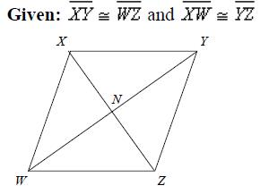  Based on the information given, can you determine that the quadrilateral must be a parallelogram? Explain
 | A. | No; you cannot determine that the quadrilateral is a parallelogram
 | B. | Yes; two opposite sides are both parallel and congruent.
 | C. | Yes; opposite sides are congruent.
 | D. | Yes; diagonals of a parallelogram bisect each other.
20. | 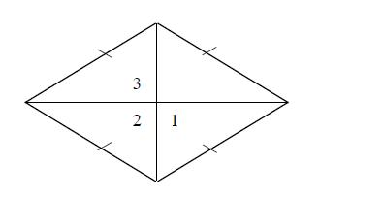  In the rhombus, m∠1 = 6x, m∠2 = x + y, and m∠3 = 18z. Find the value of each variable. The diagram is not to scale.
 | A. | x = 15, y = 165, z = 10
 | B. | x = 30, y = 75, z = 10
 | C. | x = 15, y = 75, z = 5
 | D. | x = 30, y = 165, z = 5

