GEOMETRY

2.An artist is using pieces of wire to make geometric shapes. Which three lengths could she use to make a triangle?
A) 1-, 2-, and 3-inch pieces B) 1-, 2-, and 4-inch pieces
C) 1-, 3-, and 4-inch pieces D) 2-, 3-, and 4-inch pieces
3.A large picnic table is in the shape of a regular polygon. An interior angle of this table measures 150⁰. How many sides does the picnic table have?
A) 6 B) 8 C) 10 D) 12
4.This equation represents a circle that has been graphed on a coordinate plane (x+6)²+(y-5)²=49
What ordered pair represents the center of the circle?
A) (-6, -5) B) (-6, 5) C) (6, -5) D) (6, -5)
5. Which set of points is equidistant from the rays that form an angle?
A) Perpendicular bisector B) skew line C) angle bisector D) central angle
7. Parallelogram EFGH is shown in this diagram
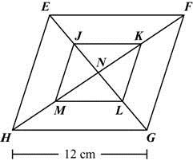
Line segments EG and FH are diagonals of parallelogram EFGH.
- Point J is the midpoint of EN Point K is the midpoint of FN
- Point L is the midpoint of GN Line segment HG is 12 cm long. What is the length of ML
Line segments EG and FH are diagonals of parallelogram EFGH.
A) 6 cm B) 7 cm C) 8 cm D) 9 cm
8. Which pair of line segments could be contained in distinct parallel lines?
A) Two radii of the same circle B) two chords of the same circle
C) two diameters of the same circle D) a radius and a diameter of the same circle
9. A student used this equation to graph a circle (x-4)²+(y+3)² = 25
The student then translated the circle 2 units up and 1 unit to the left. What is the equation of the translated circle?
A) B)
C) D)
10. In the figure below, the diagonals of parallelogram ABCD intersect at (5, 2).
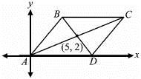
What are the coordinates of point C?
A) (7, 3) B) (8, 3) C) (9, 4) D) (10, 4)
11. The exterior angles of a triangle have a ratio. What is the smallest exterior angle of the triangle?
A) B) C) D) 160⁰
41) In the figures shown, quadrilateral G'H'I'J' is a dilation of quadrilateral GHIJ. The perimeter of GHIJ is 31.5 units.
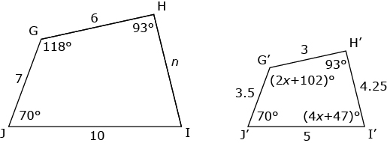
Which statement is true of the quadrilaterals?
A) The quadrilaterals are similar figures because
B) The quadrilaterals are similar figures because they have congruent angle measures and their sides are proportional.
C) The quadrilaterals are similar figures because they have proportional sides and perimeters that have a scale factor of.
D) The quadrilaterals appear to be similar figures, but you are unable to prove this because the measures of the angles cannot be determined.
44) Use this diagram and information to answer the question.
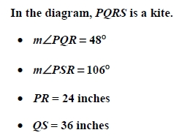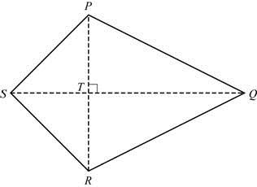
26) This diagram shows the shape of a city park. What is the value of x?
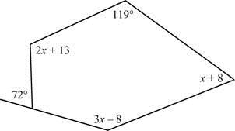
A) 20 B) 42 C) 50 D) 56
48) The measure of one exterior angle of a regular polygon is What is the sum of its interior angles?
A) B) C) D) 3960⁰

49) A clock is designed in the shape of a regular dodecagon.
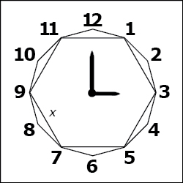
The perimeter of the dodecagon is 54 cm. By joining every other vertex of the dodecagon, a hexagon is formed. If each side of the hexagon is x cm long, what is the value of x to the nearest hundredth?
A) 6.36 B) 7.79 C) 8.69 D) 9.32

59) An electric company chose this design for its new logo.
What is the sum of the interior angles of the hexagon?
A) B) C) D)
61) Triangle the measures of its angles, and two of its side lengths are shown in this diagram.
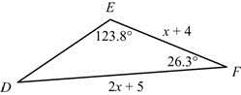
Which expression could represent the length of
A) B) C) D)
Constructed Response
1. The coordinates of the vertices of are shown on a coordinate plane.
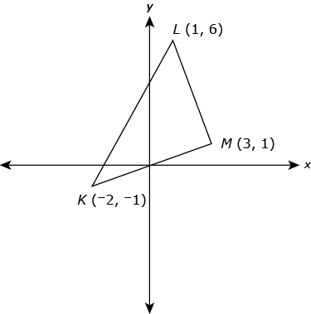
Part A
To the nearest tenth of a unit, what is the perimeter of Show your work.
Part B
Prove that triangle is a right triangle.
Part C
An altitude of is drawn from M to What is the slope of the altitude? Show your work.

2) The equation represents a circle in general form.
Part A
Find the equation of the circle in standard form. Show your work and explain each step.
Part B
What are the center and radius of the circle? Explain your answer.
Part C
Leah says that the point is on the circle. Show work to prove Leah’s statement using both forms of the equation.
Part D
Points P and Q form diameter of the circle. Point Qis located at Point X lies on What are the coordinates of X such that the ratio PX:XQ is 3:2? Show your work or explain your answer.
Part E
A new circle is drawn with the diameter of Explain whether or not this new circle is similar to the given circle. If the circles are similar, include the ratio of dilation in your explanation.
3) The coordinate plane shows and that and have the same slope.
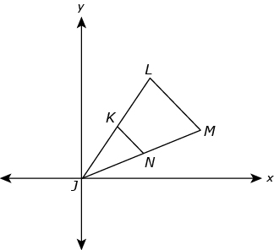
Explain how the information given determines that and are similar.
5) Two cross-sections of a cylinder are circles. How are the cross-sections related to the bases of the cylinder?
6) A circle can be circumscribed about a triangle or inscribed within a triangle.
Part A
Explain how to inscribe a circle in a triangle.
Part B
How does the construction of a circle circumscribed about a triangle compare to your explanation for Part A? Explain your answer.

7) Hema was asked to derive the formula for the area of a sector. She drew circle K that has a radius of r units. She shaded and labeled the area of sector JKL that has a central angle of The diagram shows her original circle K and then the circle with sector JKL.
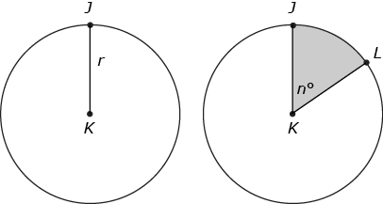
Part A
Hema used a ratio to compare the area of sector JKL to the area of the circle. If she used X to represent the area of sector JKL, what is a ratio that shows this comparison? Explain your answer.
Part B
Hema used another ratio to compare the measure of angle JKL to What is a ratio that shows this comparison?
Part C
Write a proportion that uses the two ratios you wrote in Part A and Part B. Explain why your proportion is valid.
Part D
From your answer in Part C, write the formula for X, the area of sector JKL. Explain your answer by stating the algebraic property that allows you to write your formula.

7) The equations of two circles are shown below.
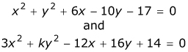
Part A
What are the center and the radius of the circle for the equation Show and explain your work.
Part B
What must be true about the value of k in order for to represent a circle? Explain your answer.

9) Circle R and circle S intersect at two points. The graph shows the centers of the circles, R and S, and one of their points of intersection, P.
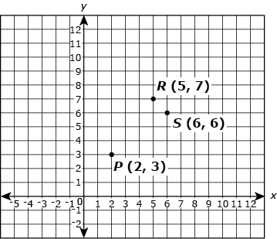
Part A
What is the equation of circle R? Explain your answer.
Part B
What is the equation of circle S? Explain your answer.
Part C
What is the second point of intersection of the circles? Explain your answer.
Part A
Quadrilateral JKLM is defined by the points and Prove whether the quadrilateral defined by the four given points is a parallelogram. Show and explain your work.
Part B
A circle is centered at point K and has a radius of 3 units. Determine whether the point lies on the circle. Show and explain your work.

An architect created a floor plan of a home that will have a hexagonal living area and two square bedrooms. The sketch of the floor plan shows hexagon PQRSTU and two congruent squares, UVWP and RYXQ.
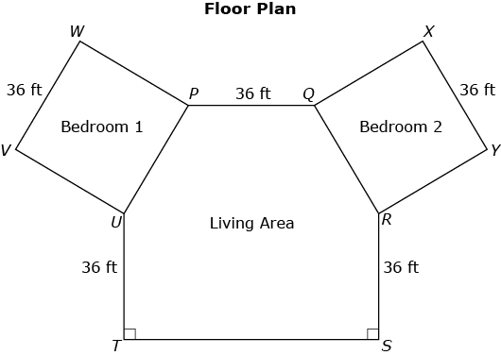
In the diagram and
Round all of your answers to the parts to the nearest tenth of a foot.
Part A
The owner wants the architect to include a deck that attaches to segment TS. What is the length of Explain your answer.
Part B
A landscaper designed a garden with a decorative fence outside the home from point V to point T. What will be the length of the fence? Explain your answer.
Part C
One part of the electrical wiring will connect from point P to some point on What is the shortest length that the wiring can be? Explain your answer.

